Lab Exercise 3- Create a Custom Resource Definition (CRD) and Custom Resource in Amazon EKS

Lab Objective
In this lab, you will:
- Connect to an Amazon EKS cluster
- Create a Custom Resource Definition (CRD)
- Extend the Kubernetes API with a new resource type called WebApplication
- Create Custom Resources based on the CRD
- Query and manage the custom resources using kubectl
- Understand how Kubernetes stores custom resources
- Prepare the foundation for building Kubernetes Operators

Lab Architecture
Amazon EKS Cluster
|
|
+---- CRD (WebApplication)
|
+---- Custom Resource
|
+---- ecommerce-app
+---- inventory-app
+---- payment-app

After completion, Kubernetes will support:
kubectl get webapplications
kubectl describe webapplication ecommerce-app

just like native resources.

Prerequisites
Verify EKS Cluster Access
Check cluster connectivity:
kubectl get nodes

Expected Output:
NAME STATUS ROLES AGE
ip-192-168-1-100.ec2.internal Ready <none> 10d
ip-192-168-2-150.ec2.internal Ready <none> 10d

Verify Current Context
kubectl config current-context
Expected Output:
arn:aws:eks:us-east-1:123456789012:cluster/dev-cluster

Task 1: View Existing CRDs
List all installed CRDs.
Kubectl get crds

Sample Output:
NAME
certificates.cert-manager.io
issuers.cert-manager.io
applications.argoproj.io

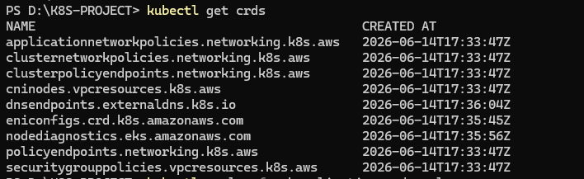
Observe that Kubernetes already contains several custom resources installed by various tools.

Task 2: Create a Custom Resource Definition
Create a file:
webapplication-crd.yaml

Paste the following CRD:
apiVersion: apiextensions.k8s.io/v1
kind: CustomResourceDefinition
metadata:
name: webapplications.apps.company.com
spec:
group: apps.company.com
names:
plural: webapplications
singular: webapplication
kind: WebApplication
shortNames:
- webapp
scope: Namespaced
versions:
- name: v1
served: true
storage: true

schema:
openAPIV3Schema:
type: object
properties:
spec:
type: object
properties:
image:
type: string
replicas:
type: integer
port:
type: integer
hostname:
type: string
required:
- image
- replicas

Task 3: Create the CRD
Deploy the CRD.
kubectl apply -f webapplication-crd.yaml

Expected Output:
customresourcedefinition.apiextensions.k8s.io/webapplications.apps.company.com created

Task 4: Verify CRD Installation
Check CRDs:
kubectl get crds

Expected Output:
webapplications.apps.company.com
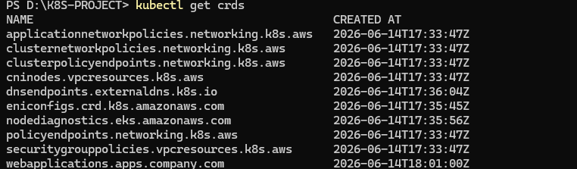

Inspect the CRD:
kubectl describe crd webapplications.apps.company.com

Observe:
- API Group
- Kind
- Version
- Validation Schema
- Scope

Task 5: Verify Kubernetes API Extension
List API resources.
Kubectl api-resources | grep web

Expected Output:
webapplications webapp apps.company.com/v1
Notice Kubernetes now recognizes the new resource type.

Task 6: Create First Custom Resource
Create:
ecommerce-app.yaml

Paste:
apiVersion: apps.company.com/v1
kind: WebApplication
metadata:
name: ecommerce-app
spec:
image: nginx
replicas: 3
port: 80
hostname: ecommerce.company.com

Deploy:
kubectl apply -f ecommerce-app.yaml

Expected Output:
webapplication.apps.company.com/ecommerce-app created

Task 7: Verify Custom Resource Creation
List resources:
kubectl get webapplications

Expected Output:
NAME
ecommerce-app

Using short name:
kubectl get webapp

Expected Output:
NAME
ecommerce-app

Task 8: Describe the Custom Resource
kubectl describe webapplication ecommerce-app

Expected Output:
Name: ecommerce-app
Namespace: default
Spec:
Hostname: ecommerce.company.com
Image: nginx
Port: 80
Replicas: 3
Observe how Kubernetes stores all custom fields.

Task 9: View Custom Resource in YAML Format
kubectl get webapplication ecommerce-app -o yaml

Observe:
apiVersion: apps.company.com/v1
kind: WebApplication
metadata:
name: ecommerce-app
spec:
hostname: ecommerce.company.com
image: nginx
port: 80
replicas: 3

Task 10: Create Multiple Web Applications
Create:
inventory-app.yaml

apiVersion: apps.company.com/v1
kind: WebApplication
metadata:
name: inventory-app
spec:
image: httpd
replicas: 2
port: 80
hostname: inventory.company.com

Deploy:
kubectl apply -f inventory-app.yaml

Create:
payment-app.yaml

apiVersion: apps.company.com/v1
kind: WebApplication
metadata:
name: payment-app
spec:
image: nginx
replicas: 4
port: 8080
hostname: payment.company.com

Deploy:
kubectl apply -f payment-app.yaml

Task 11: List All Custom Resources
kubectl get webapplications

Expected Output:
NAME
ecommerce-app
inventory-app
payment-app

Task 13: Test Schema Validation
Create an invalid resource.
invalid-app.yaml

apiVersion: apps.company.com/v1
kind: WebApplication
metadata:
name: invalid-app
spec:
replicas: 3

Deploy:
kubectl apply -f invalid-app.yaml

Expected Output:
error validating data
spec.image: Required value
This demonstrates CRD schema validation.

Task 15: Delete a Custom Resource
Delete one application.
kubectl delete webapplication payment-app

Verify:
kubectl get webapplications
Expected Output:
NAME
ecommerce-app
inventory-app

Task 17: Delete the CRD
Delete all resources first:
kubectl delete webapplication ecommerce-app
kubectl delete webapplication inventory-app

Delete CRD:
kubectl delete crd webapplications.apps.company.com

Verify:
kubectl get crds

The CRD should no longer appear.

